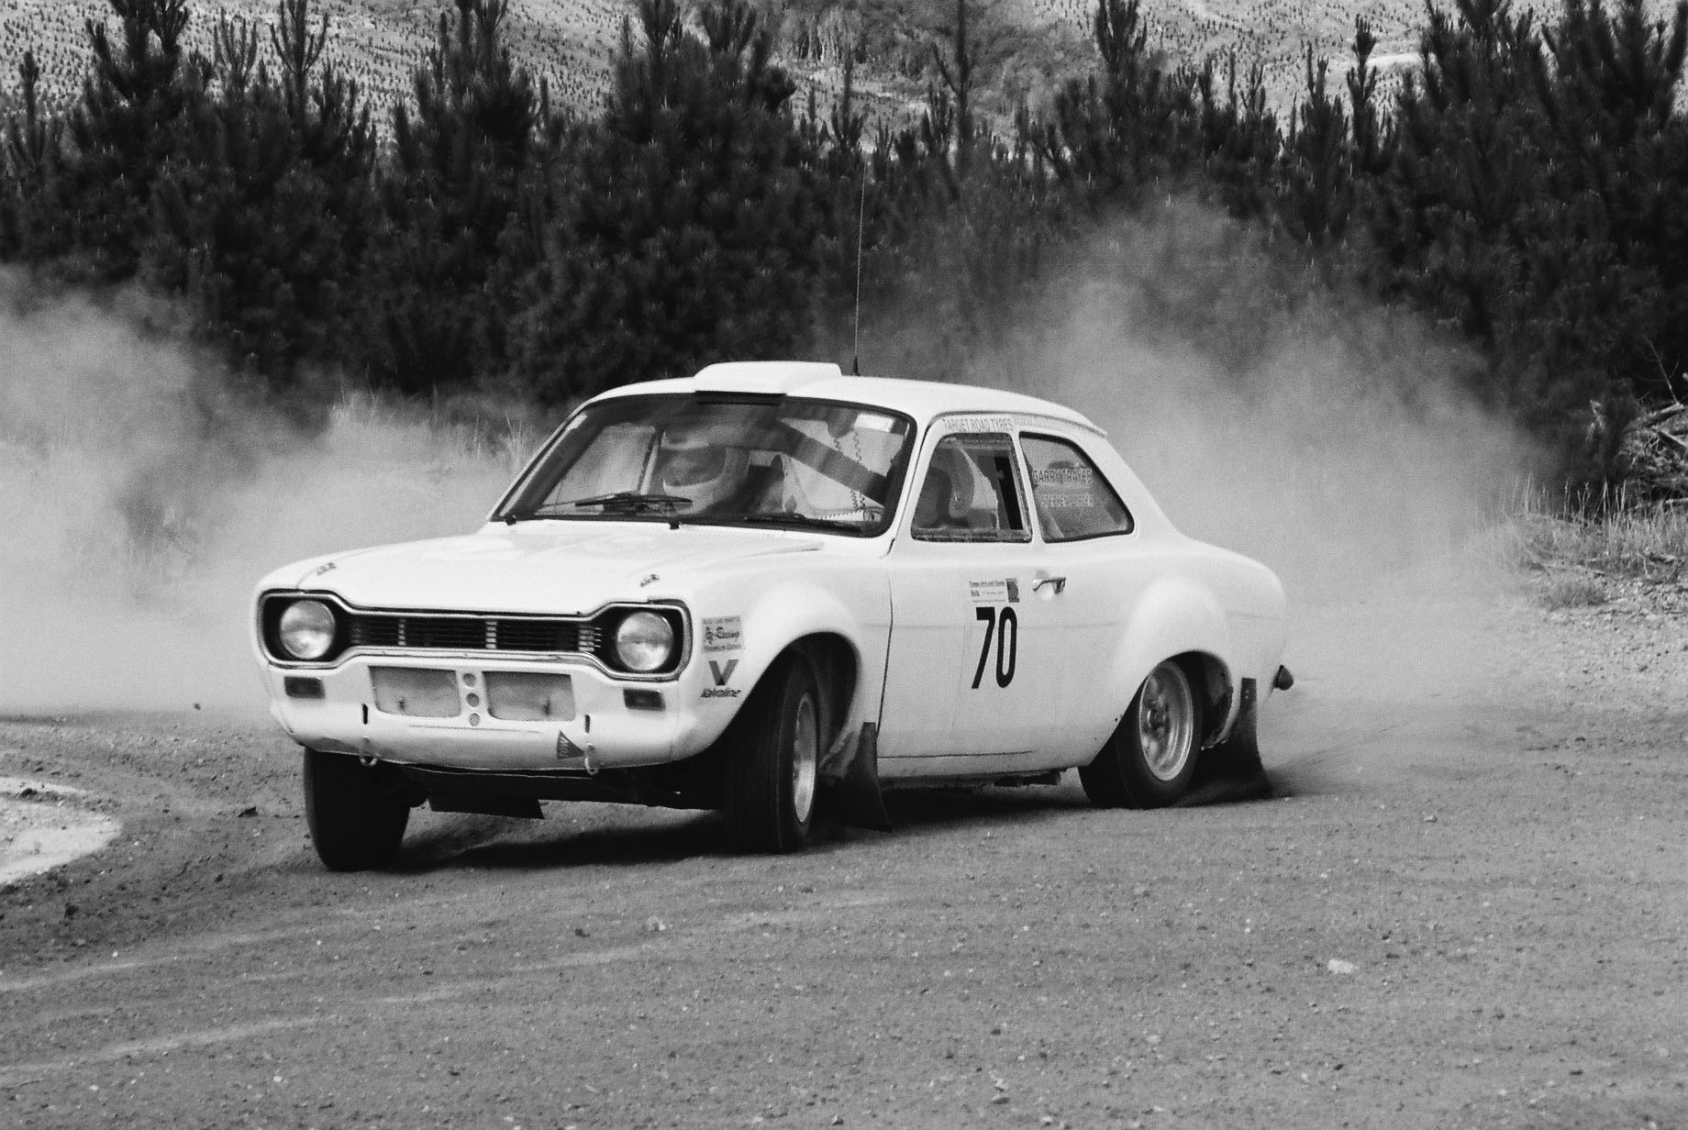


A Motorsport NZ affiliated club
www.classicrally.org.nz
Secretary@classicrally.org.nz

Taupo

www.classicrally.org.nz

Club Officer Holders for 2023

President: - Bernie Keith 027 889 8880
President@classicrally.org.nz

Secretary: - Colin Gibson 021 267 9034
Secretary@classicrally.org.nz

Treasurer: - Diana Barnes 07 3773237
Diana@twindizzy.com

Event Coordinator: - Bevan Wilson 021 0820 7395 bjwheeladdiction@gmail.com

Committee members: - Andrew Keighley 021 994 545

Alistair Steele 0274 343 500

Andrew Treseder 027 464 0202

(Gravel events): - Martin Treadwell 027 311 7341

Alan Barnes 027 443 3407

No calls after 9.00pm please

